Introduction of Good King Wenceslas
As a lover of books of antiquity, a private publication of Good King Wenceslas from 1940 is the multimodal artifact that I found to be most fitting for this assignment. I found this book at a garage sale some years ago and thought it was one of the most interesting publications I’ve seen. The binding is paper covered cardboard and unfortunately tearing from age. It holds a light red hue and in the center is stamped with what was gold inlay, “Good King Wen-ceslas,” hyphenated because it is typed within a tall vertical rectangle. The gold inlay is now a rough brown, but I could imagine how beautiful the newly printed composition was.
As we open the book, the pages are heavy and yellowed from time, and one must proceed with caution to preserve it. Half of the composition is an introduction to the purpose of the composition and the story being told, and the other half is the story. The first half of the pages appear to be torn by hand while the second half is cut precisely. There are two title pages, the first with only the title, followed by the second which includes a black and white engraving with text below it saying, “Ye who now will bless the poor Shall yourselves find blessing” (Trill 7). The framed picture appears to be of a king wearing a crown and holding a large bag, standing over a poor man on his knees struggling to gather enough wood to make a fire. The king’s servant stands behind him holding firewood, ready to deliver it to the poor man. This is followed by a two-tone title and publication page (up to this point black and red ink have both been used).
Going deeper into the composition we find a “Greetings” page that expresses the history of the story and its significance as a composition through time. The greeting expresses the composition’s attempt to reproduce the style of Furst and Schoeffer’s Psalter of 1497, which “was the first book to be printed in more than one colour from moveable types” (Trill 12). Following the “Greetings” is a most peculiar and beautiful tri-color page. Its beauty is in its style of complex printing methods and the incorporation of lyrics with composed music staff on the page. The font and language of the text appear to be from the gothic era. Following the tri-color reproduction is a note expressing the value of it that says, “Our reproduction, therefore, represents the style in which this carol would doubtlessly have been printed by one of the fathers of the “art preservative of all arts,” in the very earliest years of printing” (Trill 12) This statement exposes the true value of the composition and the attempt to preserve it.

Multimodal Rhetoric in Composition
This invaluable private publication exposes the truth of a multimodal visual-spatial and rhetorical composition through the actionable reproduction and preservation of former antiquity. What I mean to say is that the original composition was so influential that it pushed someone to recreate it, showcasing its persuasive power. As noted earlier, the original composition of Good King Wenceslas was the first of its kind breakthrough-technology of the late 1400’s, the period when Christopher Columbus was sailing across the Atlantic Ocean. It was the addition of “colour from moveable types”, and it did something inside of those who were privileged to encounter it, which it continues to do, even today (Trill 12).
To fully comprehend what the rhetoric of composition and what it is doing, we must understand the flipside of the coin. One may argue that the importance of composition is contained in the language, and not anything more. If this were true, why is it more valuable to reproduce the visual and spatial contents of a composition than only the words? Would the composition have the same intrinsic value if I transferred the words and not the style of the text? Would the reproduction of Good King Wenceslas in Arial font have the same effect in regard to the persuasive power of the original composition? The answer is no. I would have never purchased this book if it didn’t contain such multimodal complexity, thereby proving the persuasive value of the visual-spatial field of rhetoric. What I experienced when I encountered this book was something more valuable than an old composition of words on a page, I experienced a sense of awe and inspiration flowing from within.
In Jody Shipka’s book Toward a Composition Made Whole, she reflects that “the goal has been to underscore that “meanings are made, distributed, received, interpreted and remade… through many representational and communicative modes–not just through language” (Jewitt and Kress 2003, I)” (22). In other words, the meanings of things are intrinsic and extend beyond language use. Furthermore, they are interwoven in our perception and interaction with such things. Such thoughts lead us to break down our human perception, which Marilyn Cooper contends in her book Listening to Strange Strangers, Modifying Dreams, is not the answer to understanding visual-spatial rhetoric in its fullness.
Listening rather than exposition may be the key to understanding perception beyond ourselves. Marilyn Cooper summates this in her proposition aimed at broadening experience by “letting beings and things be in themselves in our relations to them; and finding new ways to listen… are ways of paying due attention to the human and nonhuman strangers we encounter” (20). Through present listening we allow an ontological makeup of rhetoric to take form, which brings an awareness to our contemplations, whereby broadening our perception of the visual-spatial world through meaning-making. Additionally, through ontological awareness, we are able to pull new meanings from things and understand more deeply the rhetorical values of multimodal visual-spatial compositions.
Within these ontological frameworks of rhetorical composition and meaning-making, we begin to see that “writing is an “ontological act” and that the language and epistemological products known as the “writer’s writing” are far less important for today than the “writer writing,” the experience and the gathering together of new ways of being” (Barnett and Casey 10). What we are able to take away from this is that the most meaningful quality of composition is the presence of the one composing, more-so than the composition itself. Herin lies the truth, that it is the action of composition and development rather than the thing developed that speaks the loudest. When we read a composition of words, we listen to a present understanding of the one writing. And when we analyze a multimodal composition, we become present with the one who made it. The beauty of a multimodal composition is that it joins the creative thoughts and cultural tendencies with the written intelligences, thereby creating harmony between the one who was inspired to write it, the one experiencing it, and the time that connects them both. This is why the multimodal composition of Good King Wenceslas is so significant, because it connects ontology through time, creativity, and inspiration, and generates rhetorical persuasion of the senses.

Conclusion and Final Thoughts
Beyond the color, the incorporation of musical lyrics, composed staff, the torn edges of the pages, and the story told, are transcendent mysteries locked within paper bindings. The timeframe of the original composition and its intrinsic value are recreated today through this experience and the authentic efforts, which were present in 1497 and 1940, that created something new and preserved the essence of antiquity. It has been brought forth as a gift to the inquisitive and open-minded through distinct efforts of multimodality. It is evident that the story of Good King Wenceslas is merely secondary to the lifeblood of the composition. In the timeframe of the original composition, the story was important, but the publisher must have felt that the expression of words was not enough to preserve the message. It was this extra effort that brought it into discussion 528 years later. Tell me that’s not persuasive…

References
Barnett, Scot and Boyle Casey. "Rhetorical Ontology, or, How to Do Things with Things." Zabrowski, Katie, et al. Rhetoric, Through Everyday Things. University of Alabama Press, 2016. 1-14. <https://open.umn.edu/opentextbooks/textbooks/721>.
Cooper, Marilyn M. "1. Listening to Strange Strangers, Modifying Dreams." Zabrowski, Katie et al. Rhetoric, Through Everyday Things. The University of Alabama Press, 2016. 17-29.
Shipka, Jody. "Chapter 1. Rethinking Composition/Rethinking Process." Shipka, Jody. Toward a Composition Made Whole. University of Pittsburgh Press, 2011. 18-38.
Trill, Hew. Good King Wenceslas. Honolulu: The Advertiser Publishing Co., LTD, 1940.

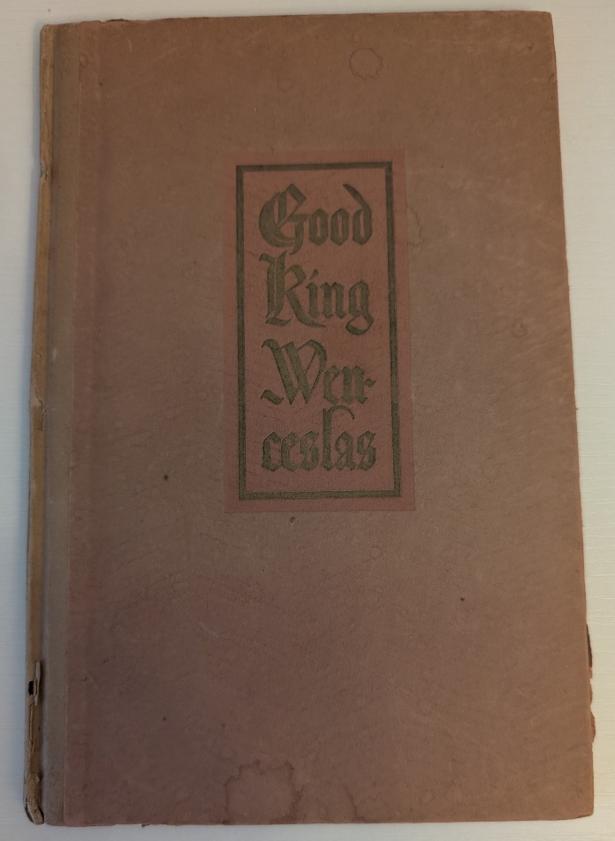
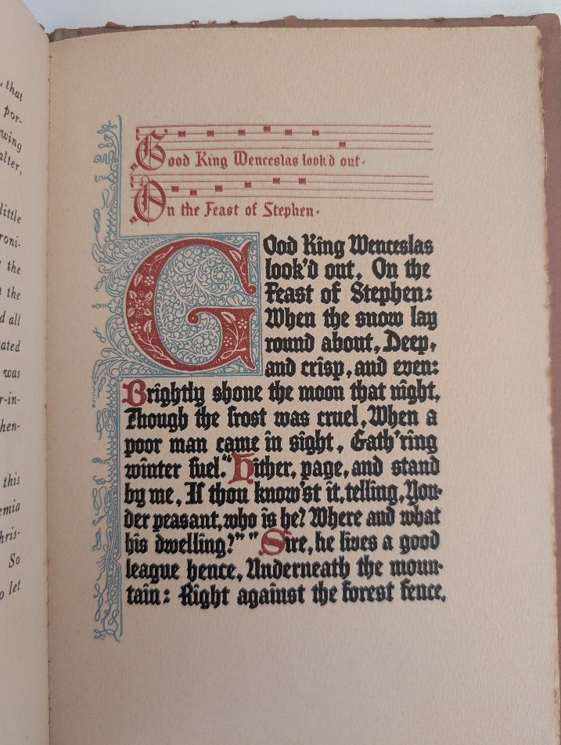
Book Cover
1497 Recreation

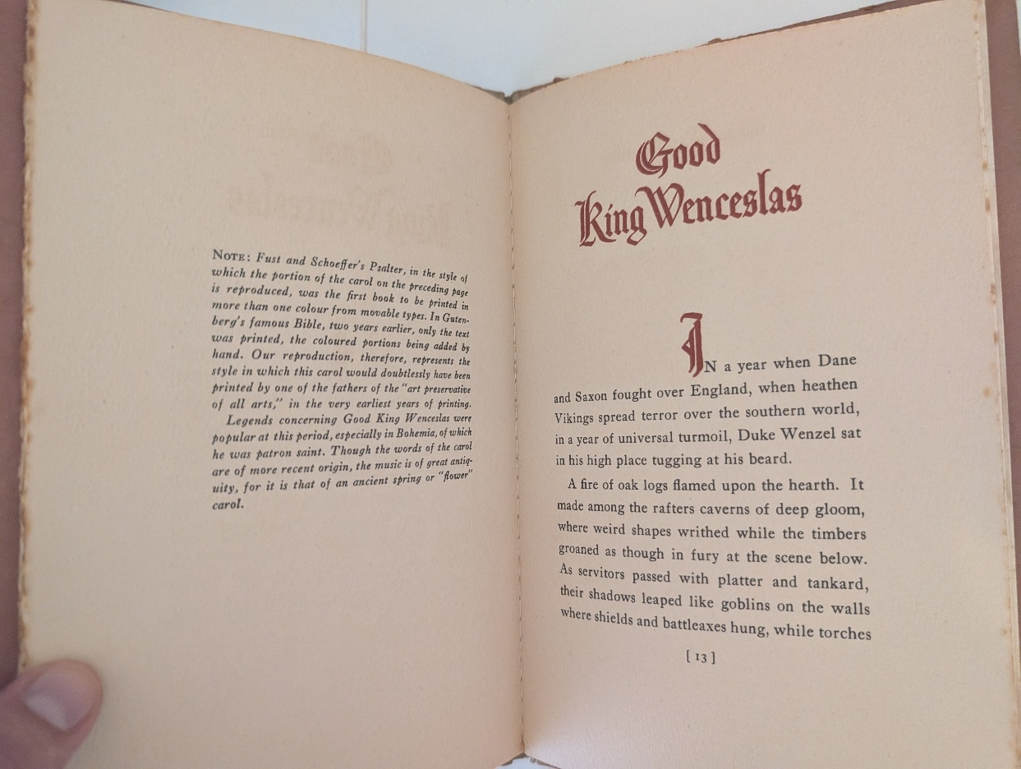
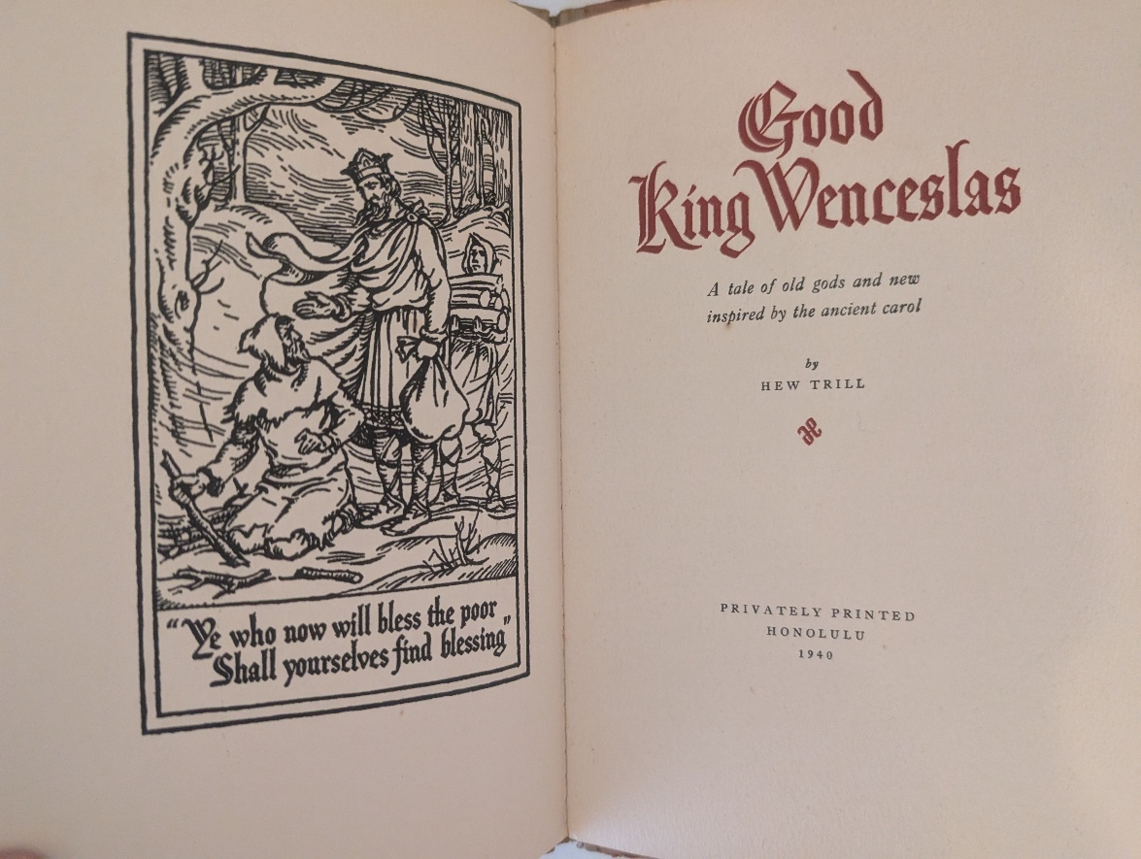
Ripped and Straight Edges
Publication Page

